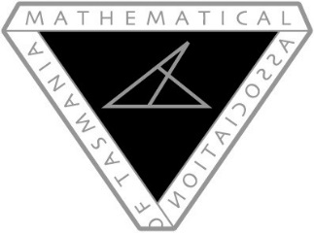
MATHEMATICAL ASSOCIATION OF TASMANIA
2016 CONFERENCE
Primed For Maths
FRIDAY MAY 13th AND SATURDAY MAY 14th
Call for Workshop Presenters

If you are interested in presenting a workshop at this year’s Mathematical Association of Tasmania’s annual conference, please complete the details below. We are particularly interested in hearing from classroom teachers willing to share their practice. Workshop presenters receive a special discounted fee.

Presenter’s name/s:
Workshop/Presentation title:
Abstract/description (for the program):

Intended audience: (please highlight as many as apply)
K-2, Primary, Middle School, Secondary, Senior Secondary
Equipment/material required:

Please submit presentation details by April 21st via email to Louise Hodgson:
Lmhod1@student.monash.edu

